**Submitted to:**

**Rezwan Ahmed**

assistant professor

Department of computer Science

American International University – bangladesh

**Submitted by:**

1. *Riyad , MD Ahsan Ferdous*

*ID:**15-29804-2*

1. Kaium, MD. AbdulID: 15-29335-1
2. Prity,Afrina JannatID: 116-32504-2
3. Siddique ,sumayaID : 15-28456-1

**Course: Advance Database Management System.**

**Section: C**

E-COmmerce website

Database Model

**Table of contents**

**Part - A**

1. Business and system summary ...................................................................................1
2. Business overview
3. Overview .............................................................................................2
4. Technical summary of super shop management system database
5. List of Entities of the model .................................................................3
6. List of attributes of the model .............................................................3
7. List of constraints according to table....................................................4
8. SQL statement to create sample table and insert sample values ........4
9. Identifying objective & describing the database working
10. Users services ......................................................................................12
11. Administrator services ........................................................................12
12. Entity – Relationship diagram (ER Diagram) ...............................................................13
13. Use Case Diagram .......................................................................................................14
14. Class Diagram ..............................................................................................................15
15. Activity Diagram ..........................................................................................................16
16. Normalization .............................................................................................................17
17. Relationship diagram ..................................................................................................18
18. Screenshots of the table with only data type of the attributes....................................20
19. Screenshot of the tables with sample data records ....................................................24
20. Demonstrating some database use scenarios and SQL queries...................................27

**Part - B**

Summarizing learning experience from database project ..............................................30

* **Part - A**

**Business and system summary**

E-commerce also known as Electronic commerce is the most useful business over the internet.it refers to buy and sell of good products on global scale. This project deals with an e-commerce website for online shopping system. The Online Shopping System is a web based application for an existing shop. The main thing of the Online Shopping System is to manage all the information about shopping, products and customers. It would help to easily searching, viewing and selection of a product in any shop through internet by using any web browser. Customer can get the services without going to the market. This system provides a cart to a customer and customer can add a product to the shopping cart. It is easily accessible and always available.

**Business overview**

Online Shopping System is a virtual store where the customers buy the product of interest. The Customers can search the details of products easily and select the product from different catalogue. The selected product may be collected in shopping cart. Customers can add a product to cart for purchase or delete a product from cart before selecting the final submission. After giving order, the product will deliver to the customer via Post office or currier services. Customer can also view products review and comment out their own review. A customer must have to be registered if they want to buy something. Every customer have a separate identity .Online shop has so many products. The products have to be identified as product type. Sometimes customer got commission by selling a fixed amount.Online Shopping System is not really much complicated.But sometimes the system can get much more complicated if it is not organized properly.

**Technical summary of super shop management system database**

The database system that prepared in this project can be accessed via a software program or a web-server based system using internet access or as an embedded data storage system. The database system and the project was made using Oracle SQL Express 10g, Microsoft Word. The interface connection for backend service was activated oracle 18c and node js.The database system is very simple in design and to implement. This system requires very low system resources and this system will work in almost all configurations.

**List of Entities of the model:**

* Admin
* Seller
* User
* Product
* Supply_Order
* Order
* Promo
* Cart
* Category

**List of attributes of the model:**

* **Admin’s Attributes** :

|  |  |  |  |  |  |  |
| --- | --- | --- | --- | --- | --- | --- |
| **Attributes** | A_id | A_password | A_address | A_email | A_mobile | U_status |
| **Data Type** | number(5) | varchar2(15) | varchar2(30) | varchar2(30) | number(11) | varchar2(30) |

* **Seller’s Attributes:**

|  |  |  |  |  |  |  |
| --- | --- | --- | --- | --- | --- | --- |
| **Attributes** | S_id | S_password | S_address | S_email | S_mobile | U_status |
| **Data Type** | number(5) | varchar2(30) | varchar2(30) | varchar2(30) | number(11) | varchar2(30) |

* **G_user’s Attributes:**

|  |  |  |  |  |  |  |
| --- | --- | --- | --- | --- | --- | --- |
| **Attributes** | G_u_id | Gu_password | Gu_address | Gu_email | Gu_mobile | u_status |
| **Data Type** | number(5) | varchar2(15) | varchar2(30) | varchar2(30) | number(11) | varchar2(30) |

* **Product’s attributes :**

|  |  |  |  |  |  |  |  |
| --- | --- | --- | --- | --- | --- | --- | --- |
| **Attributes** | product_id | product_name | product_price | product_avlble | product_sell_price | product_orginal _price | Category_id |
| **Data Type** | number(5) | varchar2(30) | varchar2(30) | varchar2(30) | number(5) | number(5) | number(5) |

* **Supply order attributes :**

|  |  |  |  |  |
| --- | --- | --- | --- | --- |
| **Attributes** | Supply_id | Supply_date | Supply_status | S_id |
| **Data Type** | number(5) | number(10) | varchar2(30) | number(5) |

* **Cart’s attributes (updated):**

|  |  |  |  |  |
| --- | --- | --- | --- | --- |
| **Attributes** | cart_id | cart_status | user_id | Order_id |
| **Data Type** | number(5) | varchar2(30) | number(5) | number(5) |

* **Order_t attributes :**

|  |  |  |  |  |  |
| --- | --- | --- | --- | --- | --- |
| **Attributes** | order_id | order_date | payment_method | payment_status | return_id |
| **Data Type** | number(5) | number(20) | varchar2(30) | varchar2(30) | number(5) |

* **Categories attributes :**

|  |  |  |
| --- | --- | --- |
| **Attributes** | Category_id | Category_name |
| **Data Type** | number(5) | varchar2(30) |

* **Promo_use attributes :**

|  |  |  |  |  |
| --- | --- | --- | --- | --- |
| **Attributes** | Promo_id | user_id | user_use_date | user_use_account |
| **Data Type** | number(5) | number(5) | number(22) | number(20) |

**List of constraints according to table:**

|  |  |  |
| --- | --- | --- |
| **Table Name** | **Constraint Name** | **Constraint Attribute** |
| G_user | G_user_pk | g_u_id |
| Seller | Seller_pk | S_id |
| Admin | Admin_pk | A_id |
| Orders | Orders_pk | Order_ID |
| Products | Products_pk | p_ID |
| Supply_order | supply_order_pk | supply_id |
| cart | cart_pk | cart_id |
| Category | category_pk | category_id |
| promo | promo_pk | promo_id |

**SQL statement to create sample table and insert sample values:**

create table Admin

(

a_id number(5),

a_password varchar2(15),

a_address varchar2(30) not null,

a_email varchar2(30) unique,

a_mobile number(11) not null,

u_status varchar2(30) not null,

CONSTRAINT Admin_pk PRIMARY KEY (a_id)

);

insert into Admin values('11','12','sirajgonj','nishi@gmail.com','01111','valid');

insert into Admin values('12','12','sirajgonj','nish2@gmail.com','01111','valid');

insert into Admin values('13','12','sirajgonj','nish3@gmail.com','01111','valid');

insert into Admin values('14','12','sirajgonj','nish4@gmail.com','01111','valid');

insert into Admin values('15','12','sirajgonj','nish5@gmail.com','01111','valid');

create table Seller

(

s_id number(5) ,

s_password varchar2(30),

s_address varchar2(30),

s_email varchar2(30) unique,

s_mobile number(11) unique,

u_status varchar2(30) not null,

constraint Seller_pk primary key(s_id )

);

insert into Seller values('21','orange','tangail','jannat@gmail.com','019437438','valid');

insert into Seller values('22','orange','tangail','jannat2@gmail.com','0194374382','valid');

insert into Seller values('23','orange','tangail','jannat3@gmail.com','0194374383','valid');

insert into Seller values('24','orange','tangail','jannat4@gmail.com','0194374384','valid');

insert into Seller values('25','orange','tangail','jannat5@gmail.com','0194374385','valid');

create table G_user

(

g_u_id number(5),

g_u_password varchar2(15),

g_u_address varchar2(30) not null,

g_u_email varchar2(30) unique,

g_u_mobile number(11) not null,

u_status varchar2(30) not null,

constraint g_user_pk primary key(g_u_id )

);

insert into G_user values('31','orange','tangail','jannat1@gmail.com','019437438','valid');

insert into G_user values('32','orange','tangail','jannat2@gmail.com','019437438','valid');

insert into G_user values('33','orange','tangail','jannat3@gmail.com','019437438','valid');

insert into G_user values('34','orange','tangail','jannat4@gmail.com','019437438','valid');

insert into G_user values('35','orange','tangail','jannat5@gmail.com','019437438','valid');

create table Seller_name

(

s_id number(5),

first_name varchar2(30),

last_name varchar2(30),

constraint s_id_fk foreign key(s_id) references Seller(s_id),

constraint seller_name_pk primary key (s_id )

);

CREATE TABLE Admin_name

( a_id NUMBER(5),

first_name varchar2(30),

last_name varchar2(30),

CONSTRAINT a_id_fk FOREIGN KEY (a_id)

REFERENCES Admin (a_id),

constraint admin_name_pk primary key (a_id )

);

CREATE TABLE G_user_name

( g_u_id NUMBER(5),

first_name varchar2(30),

last_name varchar2(30),

CONSTRAINT g_u_id_fk FOREIGN KEY (g_u_id)

REFERENCES G_user (g_u_id),

constraint g_u_name_pk primary key (g_u_id )

);

create table Promo

(

promo_id number(5),

promo_desc varchar2(30),

Promo_expiry date ,

promo_percentage number(10),

promo_status varchar2(20),

promo_limit number(10),

promo_use_count number(10),

a_id number(5),

CONSTRAINT Promo_pk PRIMARY KEY (promo_id),

CONSTRAINT a_idi_fk FOREIGN KEY (a_id) REFERENCES Admin(a_id)

);

insert into Promo values('1','pri',(TO_DATE('2003/05/03 21:02:44', 'yyyy/mm/dd hh24:mi:ss')),50,'valid','limited',34,11);

insert into Promo values('2','pri',(TO_DATE('2003/05/03 21:02:44', 'yyyy/mm/dd hh24:mi:ss')),50,'valid','limited',34,11);

insert into Promo values('3','pri',(TO_DATE('2003/05/03 21:02:44', 'yyyy/mm/dd hh24:mi:ss')),50,'valid','limited',34,11);

insert into Promo values('4','pri',(TO_DATE('2003/05/03 21:02:44', 'yyyy/mm/dd hh24:mi:ss')),50,'valid','limited',34,11);

insert into Promo values('5','pri',(TO_DATE('2003/05/03 21:02:44', 'yyyy/mm/dd hh24:mi:ss')),50,'valid','limited',34,11);

create table Promo_use

(

promo_id number(5),

user_id number(5),

user_type varchar2(30),

user_use_date date,

user_use_count number(20),

CONSTRAINT promid_fk FOREIGN KEY (promo_id) REFERENCES Promo(promo_id),

CONSTRAINT promid_user_fk FOREIGN KEY (user_id) REFERENCES G_user(g_u_id ),

CONSTRAINT Promo_use_pk PRIMARY KEY (user_id , promo_id)

);

insert into Promo_use values('1','31','user',to_date('09-02-19','dd-mm-yyyy'),'23');

insert into Promo_use values('2','31','user',to_date('09-02-19','dd-mm-yyyy'),'23');

insert into Promo_use values('3','31','user',to_date('09-02-19','dd-mm-yyyy'),'23');

insert into Promo_use values('4','31','user',to_date('09-02-19','dd-mm-yyyy'),'23');

insert into Promo_use values('5','31','user',to_date('09-02-19','dd-mm-yyyy'),'23');

create table Categories

(

category_id number(5),

category_name varchar2(30),

CONSTRAINT Categories_pk PRIMARY KEY (category_id)

);

insert into Categories values('1','first');

insert into Categories values('2','second');

insert into Categories values('3','first');

insert into Categories values('4','first');

insert into Categories values('5','first');

create table Products

(

product_id number(5),

product_name varchar2(30) ,

product_price varchar2(30) ,

product_avlble varchar2(30) ,

product_sell_price number(5) ,

product_original_price number(5) ,

category_id number(5),

CONSTRAINT Products_pk PRIMARY KEY (product_id),

CONSTRAINT Products_fk FOREIGN KEY (category_id) REFERENCES Categories(category_id)

);

ALTER TABLE Products

MODIFY product_price number;

ALTER TABLE Products

MODIFY product_avlble number;

insert into Products values(1,'soap',100,200, 100,80,1);

insert into Products values(2,'soap',100,200, 100,80,1);

insert into Products values(3,'soap',100,200, 100,80,1);

insert into Products values(4,'soap',100,200, 100,80,1);

insert into Products values(5,'soap',100,200, 100,80,1);

create table Order_t

(

order_id number(5),

order_date date,

payment_method varchar2(30),

payment_status varchar2(30),

CONSTRAINT Order_t_pk PRIMARY KEY (order_id)

)

insert into Order_t values(1,to_date('09-09-18','dd-mm-yyyy'),'cash','pending');

insert into Order_t values(2,to_date('09-09-18','dd-mm-yyyy'),'cash','pending');

insert into Order_t values(3,to_date('09-09-18','dd-mm-yyyy'),'cash','pending');

insert into Order_t values(4,to_date('09-09-18','dd-mm-yyyy'),'cash','pending');

insert into Order_t values(5,to_date('09-09-18','dd-mm-yyyy'),'cash','pending');

create table Cart

(

cart_id number(5),

cart_status varchar2(30) ,

g_u_id number(5),

order_id number(5),

CONSTRAINT Cart_pk PRIMARY KEY (cart_id),

CONSTRAINT userid1_fk FOREIGN KEY (g_u_id) REFERENCES G_user(g_u_id),

CONSTRAINT orderid1_fk FOREIGN KEY (order_id) REFERENCES Order_t(order_id)

);

insert into Cart values(1,'cart',31 ,1);

insert into Cart values(2,'cart',31 ,1);

insert into Cart values(3,'cart',31 ,1);

insert into Cart values(4,'cart',31 ,1);

insert into Cart values(5,'cart',31 ,1);

create table P_include_cart

(

cart_id number(5),

product_id number(5) ,

product_qntity number(5) ,

constraint P_include_cart_pk primary key(cart_id , product_id),

CONSTRAINT cartid3_fk FOREIGN KEY (cart_id) REFERENCES Cart(cart_id),

CONSTRAINT productid2_fk FOREIGN KEY (product_id) REFERENCES Products(product_id)

);

ALTER TABLE P_include_cart

MODIFY product_qntity number;

insert into P_include_cart values(1,1,1);

insert into P_include_cart values(2,1,1);

insert into P_include_cart values(3,1,1);

insert into P_include_cart values(4,1,1);

insert into P_include_cart values(5,1,1);

create table Supply_order

(

supply_id number(5),

supply_date date ,

supply_status varchar2(30),

s_id number(5),

CONSTRAINT Supply_order_pk PRIMARY KEY (supply_id),

CONSTRAINT sid3_fk FOREIGN KEY (s_id) REFERENCES Seller(s_id)

);

insert into Supply_order values(1,to_date('09-06-18','dd-mm-yyyy'),'valid' , 21);

insert into Supply_order values(2,to_date('09-06-18','dd-mm-yyyy'),'valid' , 21);

insert into Supply_order values(3,to_date('09-06-18','dd-mm-yyyy'),'valid' , 21);

insert into Supply_order values(4,to_date('09-06-18','dd-mm-yyyy'),'valid' , 21);

insert into Supply_order values(5,to_date('09-06-18','dd-mm-yyyy'),'valid' , 21);

create table Supply_contains

(

supply_id number(5),

product_id number(5),

product_qntity varchar2(30) ,

CONSTRAINT supplyid1_fk FOREIGN KEY (supply_id) REFERENCES Supply_order(supply_id),

CONSTRAINT productid3_fk FOREIGN KEY (product_id) REFERENCES Products(product_id),

CONSTRAINT Supply_contains_pk PRIMARY KEY (supply_id , product_id)

);

ALTER TABLE Supply_contains

MODIFY product_qntity number;

insert into Supply_contains values(1,1,1);

insert into Supply_contains values(2,1,1);

insert into Supply_contains values(3,1,1);

insert into Supply_contains values(4,1,1);

insert into Supply_contains values(5,1,1);

create table review

(

review_id number(5),

review_text varchar2(30),

review_status varchar2(30),

review_date date ,

product_id number(5),

CONSTRAINT review_pk PRIMARY KEY (review_id),

CONSTRAINT productid4_fk FOREIGN KEY (product_id) REFERENCES Products(product_id)

);

insert into review values(1,'post','user',to_date('09-05-18','dd-mm-yyyy'),1);

insert into review values(2,'post','user',to_date('09-05-18','dd-mm-yyyy'),1);

insert into review values(3,'post','user',to_date('09-05-18','dd-mm-yyyy'),1);

insert into review values(4,'post','user',to_date('09-05-18','dd-mm-yyyy'),1);

insert into review values(5,'post','user',to_date('09-05-18','dd-mm-yyyy'),1);

create table Give_review

(

review_id number(5),

user_id number(5),

s_id number(5),

CONSTRAINT Give_review_pk PRIMARY KEY (review_id , user_id , s_id ),

CONSTRAINT review2_fk FOREIGN KEY (review_id) REFERENCES review(review_id),

CONSTRAINT sid4_fk FOREIGN KEY (s_id) REFERENCES Seller(s_id),

CONSTRAINT userid5_fk FOREIGN KEY (user_id) REFERENCES G_user(g_u_id )

);

insert into Give_review values(1,31,21);

insert into Give_review values(2,31,21);

insert into Give_review values(3,31,21);

insert into Give_review values(4,31,21);

insert into Give_review values(5,31,21);

Thus how the database system was created by following above pattern. The data types are shown in the table charts and all entities and attributes names as well. This database is following joining function of DBMS between the tables and the tables are linked with each other with the foreign keys. By these foreign keys these tables are connected with each other. In those tables any suitable and eligible type of data and especially appropriate data can be stored or modify.

**Identifying objective & describing the database working**

Our objective is to make a website for a company to start an E-Commerce business. The website will contain varities of products like electronics, garments , groceries etc. This website will have 3 types of users,

1. Consumer/Regular User/Visitor
2. Seller
3. Admin

In the website, all users can

1. registration
2. login
3. view and update their profile information.

Aditionally the general users will be able to do the following task:

1. User can visit product from different product categories.
2. Choose Products to save into Wishlish and Cart
3. In future or instantly, they can buy it from the cart or wishlist.
4. User can pay immediately using different payment method
5. Instead of paying instantly they can choose to pay cash on delivery
6. After making an order , user can show order list and check current status of an order.
7. If there is any problem in product, user can request for return.
8. User can contact customer service using a message box.

Admin will have the following unique functionality:

1. Can create, delete/block, aprrove user/seller/admin
2. Manipulate product (approve/reject/update)
3. Add/Update promocode
4. Reply to the query from other user
5. Can manipulate the order info/status
6. Can approve/reject/remove the review of product

Seller can enjoy the following additonal features:

1. Can request to add a product
2. Update the stock of a product
3. Can aprrove a product request from admin/user
4. Send message to the admin
5. Check revenue dashboard
6. Check product order status
7. Can reply to review or answer questions

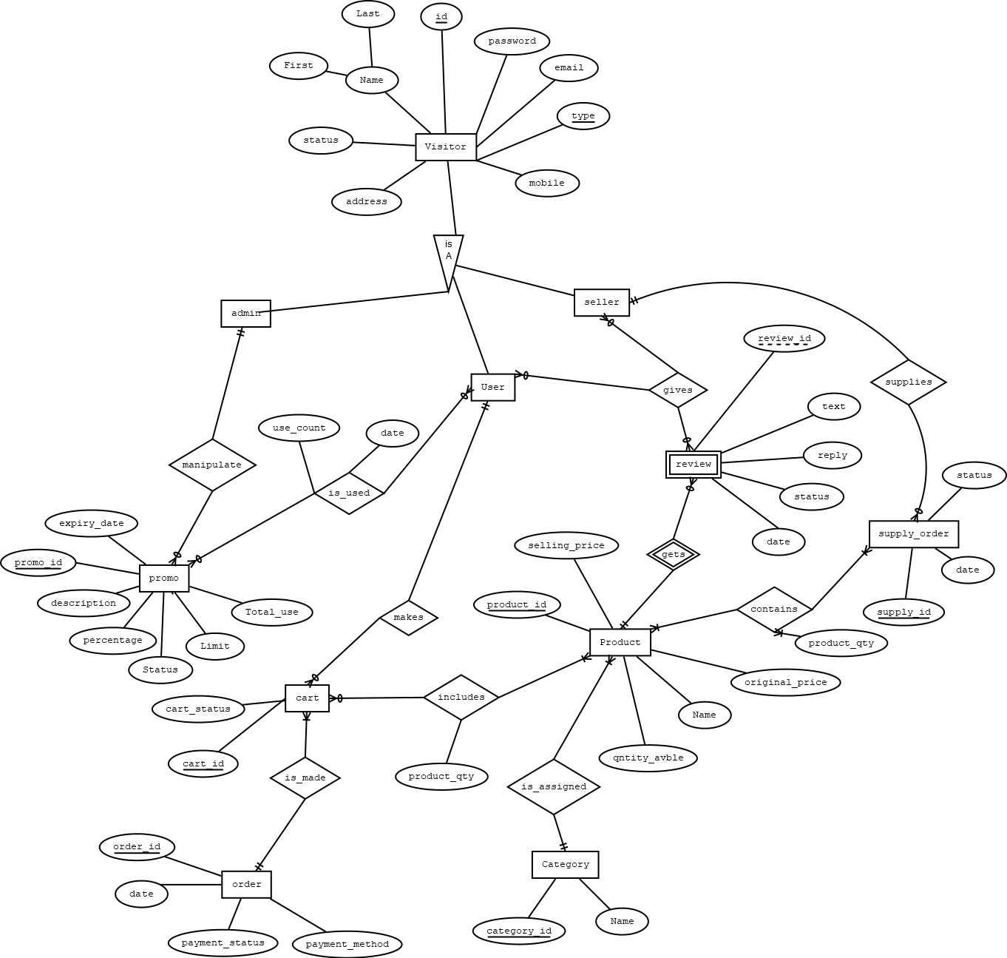**Entity – Relationship diagram (ER Diagram)**

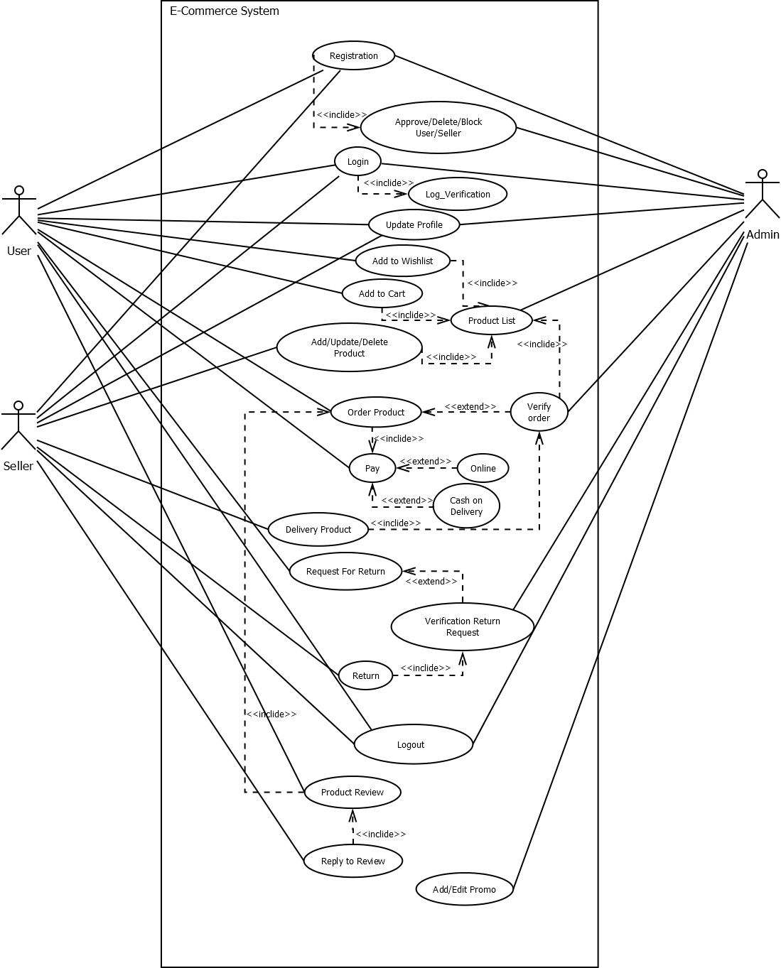**Use Case Diagram**

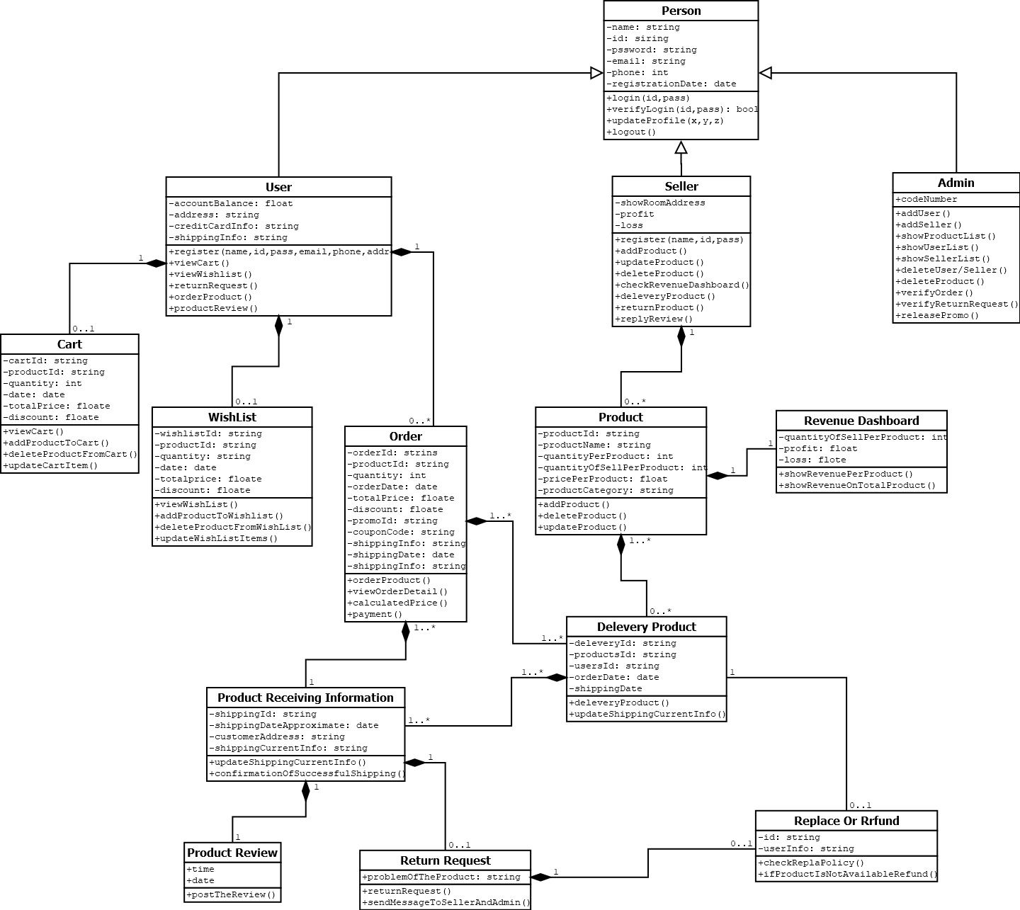**Class Diagram**

**Normalization (upto 3NF)**

1. Admin:

|  |  |  |  |  |  |
| --- | --- | --- | --- | --- | --- |
| a_id | a_password | a_address | a_email | a_mobile | u_status |

1. Seller:

|  |  |  |  |  |  |
| --- | --- | --- | --- | --- | --- |
| s_id | s_password | s_address | s_email | s_mobile | u_status |

1. G_user:

|  |  |  |  |  |  |
| --- | --- | --- | --- | --- | --- |
| g_u_id | g_u_password | g_u_address | g_u_email | g_u_mobile | u_status |

1. Multivalued attribute for admin:

Seller_name

|  |  |  |
| --- | --- | --- |
| s_id | first_name | last_name |

1. Multivalued attribute for seller:

Admin_name

|  |  |  |
| --- | --- | --- |
| a_id | first_name | last_name |

1. Multivalued attribute for g_user:

G_user_name

|  |  |  |
| --- | --- | --- |
| g_u_id | first_name | last_name |

1. Promo:

|  |  |  |  |  |
| --- | --- | --- | --- | --- |
| promo_id | promo_desc | Promo_expiry | promo_percentage | promo_status |
| promo_limit | promot_use_count | a_id |

1. Promo_use:

|  |  |  |  |
| --- | --- | --- | --- |
| promo_id | user_id | user_use_date | user_use_count |

1. P_include_cart:

|  |  |  |
| --- | --- | --- |
| cart_id | product_id | product_qntity |

1. Cart:

|  |  |  |  |
| --- | --- | --- | --- |
| cart_id | cart_status | user_id | order_id |

1. Order_t:

|  |  |  |  |  |
| --- | --- | --- | --- | --- |
| order_id | order_date | payment_method | payment_status | return_id |

1. Products:

|  |  |  |  |  |  |
| --- | --- | --- | --- | --- | --- |
| product_id | product_name | product_price | product_avlble | product_sell_price | product_original_price |
| category_id |

1. Categories:

|  |  |
| --- | --- |
| category_id | category_name |

1. Supply_order:

|  |  |  |  |
| --- | --- | --- | --- |
| supply_id | supply_date | supply_status | s_id |

1. Supply_contains:

|  |  |  |
| --- | --- | --- |
| supply_id | product_id | product_qntity |

1. review:

|  |  |  |  |  |
| --- | --- | --- | --- | --- |
| review_id | review_text | review_status | review_date | product_id |

1. Give_review:

|  |  |  |
| --- | --- | --- |
| review_id | user_id | s_id |

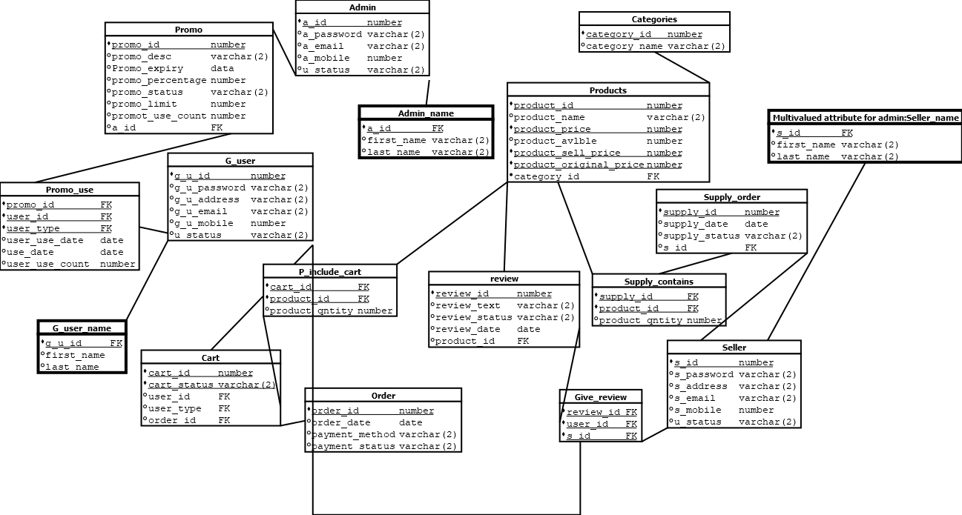**Relationship diagram (Schema Diagram)**

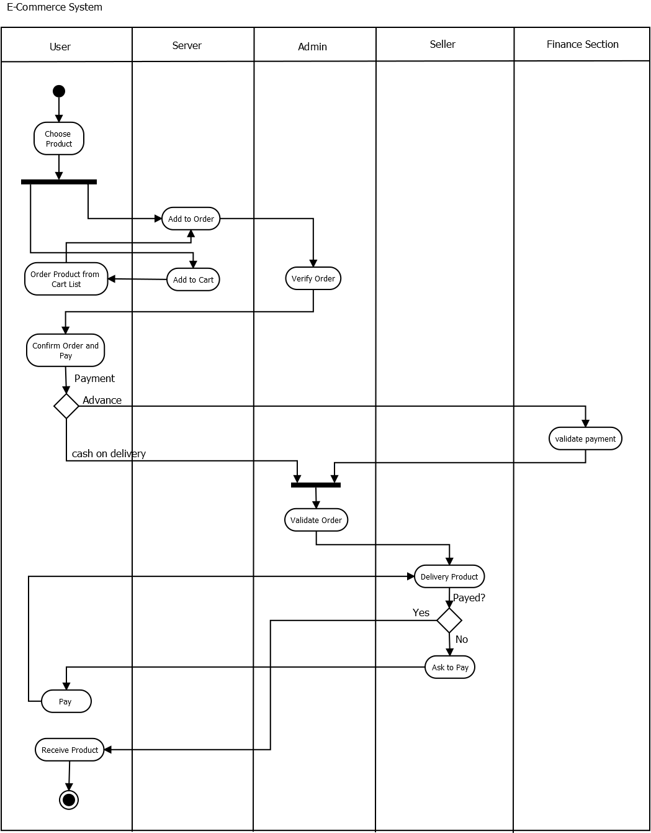**Activity Diagram**

**Screenshots of the table with only data type of the attributes**

**G_user:**

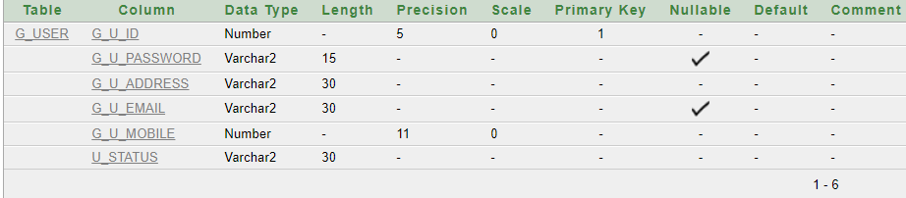

**Admin:**

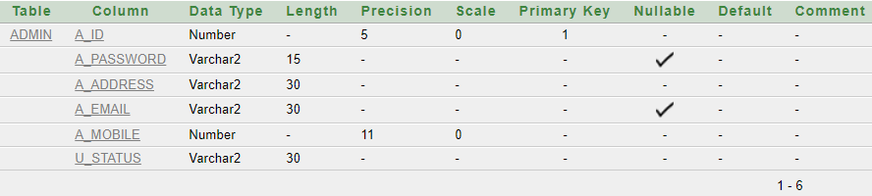

**Seller:**

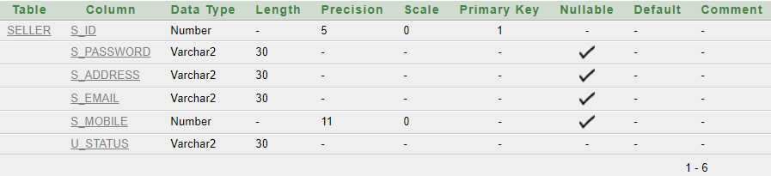

**Seller_name:**

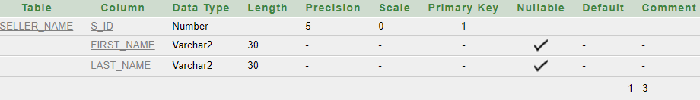

**Promo:**

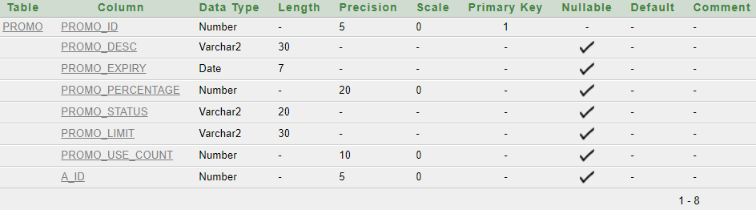

**Promo_use:**

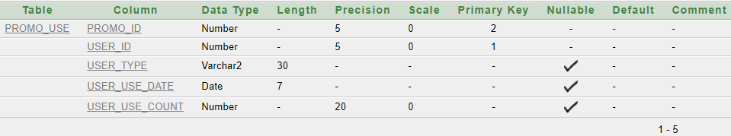

**Categories:**

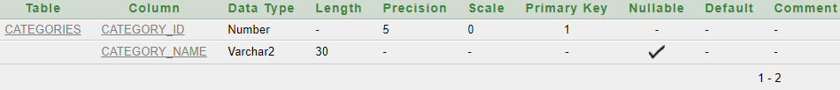

**Supplier:**

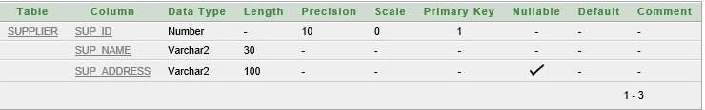

**Products:**

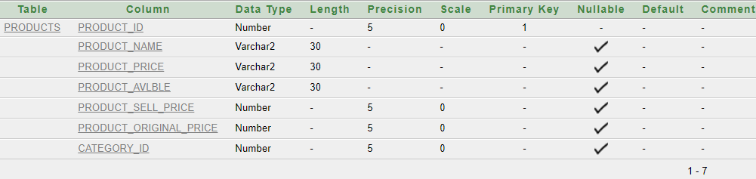

**Order_t:**

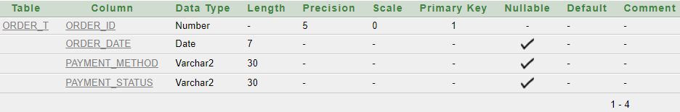

**Cart:**

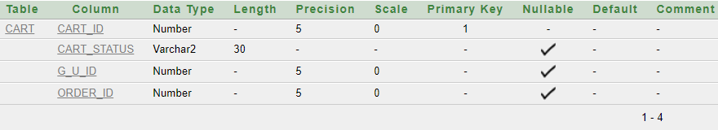

**P_include_cart:**

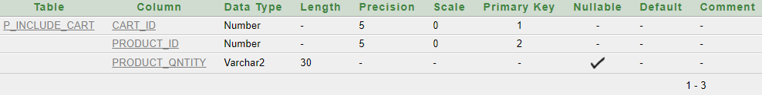

**Supply_order:**

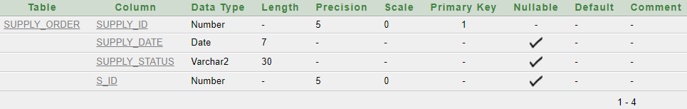

**Supply_contains:**

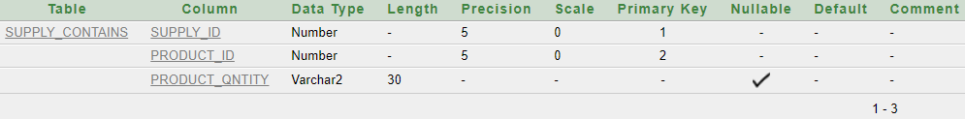

**Review:**

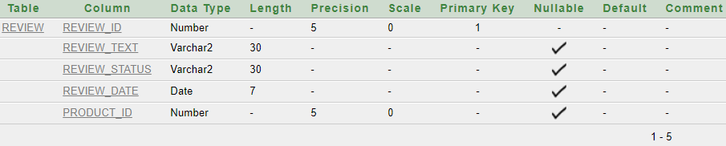

**Give_review:**

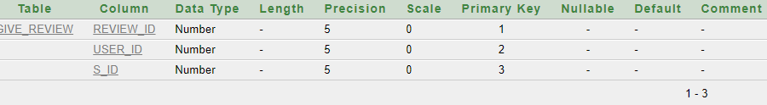

**Screenshot of the tables with sample data records**

**G_user:**

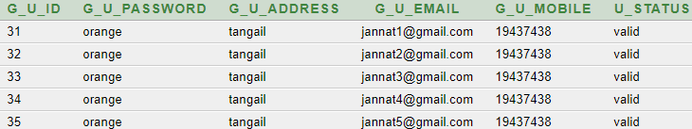

**Admin:**

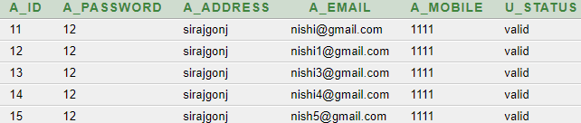

**Seller:**

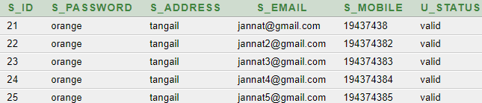

**Promo:**

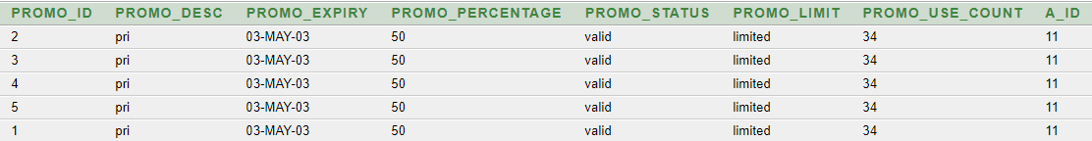

**Categories:**

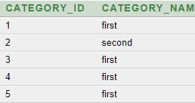

**seller:**

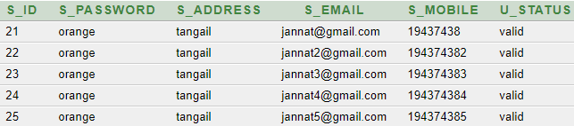

**Products:**

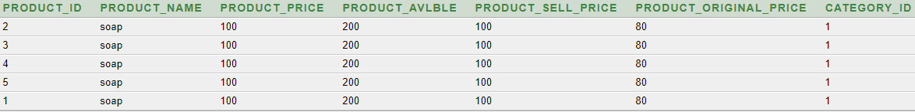

**Order_t:**

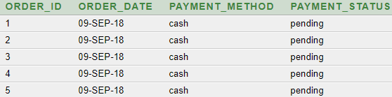

**Cart:**

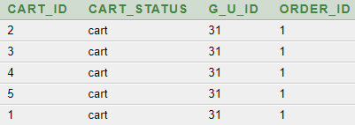

**P_include_cart:**

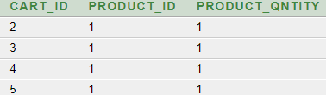

**Supply_order:**

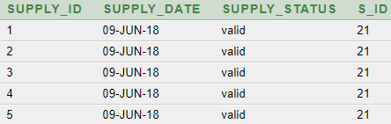

**Review:**

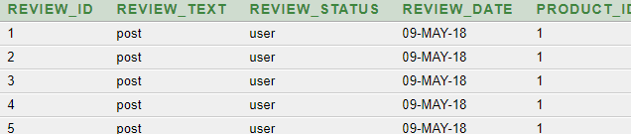

**Demonstrating some database use scenarios and SQL queries**

1. Find out seller info,prduct_id,product_price,category who sells shampoo

select Seller.s_id,Seller.s_address,Supply_order.supply_date,products.product_name,product_id,products.product_price,categories.category_name from Seller,Supply_order,products,categories where products.category_id=categories.category_id and Seller.s_id=Supply_order.s_id and product_name='shampoo'

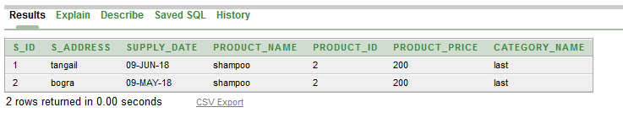

1. Display Maximum selling product product_price group by Product id

select products.product_id,max(products.product_price) from products,supply_contains where products.product_id=supply_contains.product_id group by products.product_id

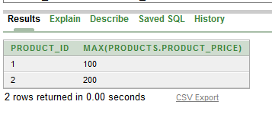

1. Generate a bill for order number 2

*select o.order_no , o.order_date , c.c_id , c.c_name , p.p_id , p.p_name , con.con_quantity , p.sell_unit_price , s.s_id , s.s_name , con.con_quantity*p.sell_unit_price as "Total" from orders o , contains con , sales_man s , customers c , products p , places pl where o.order_no = pl.order_no and pl.c_id = c.c_id and o.order_no = con.order_no and o.s_id = s.s_id and con.p_id = p.p_id and o.order_no = 2*



1. Display total supply of the store

*select supo.sup_order_id , supo.sup_order_date , inc.p_id , p.p_name , inc.inc_quantity , supplies.sup_date , supl.sup_id , supl.sup_name , br.br_id , br.br_name from products p , includes inc , branch br , sup_order supo , supplies , supplier supl where p.p_id = inc.p_id and inc.sup_order_id = supo.sup_order_id and supo.sup_order_id = supplies.sup_order_id and supo.br_id = br.br_id and supplies.sup_id = supl.sup_id order by supo.sup_order_id asc*

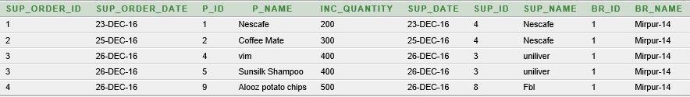

1. 3. Display product supplied , sold and remaing number by Product id

*select c.p_id , sum(c.con_quantity) as "Sold" , sum(i.inc_quantity) as "Supplied" , (sum(i.inc_quantity)-sum(c.con_quantity)) as "Remaining" from contains c , includes i , products p where c.p_id = i.p_id and i.p_id = p.p_id group by c.p_id order by c.p_id*

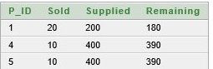

1. Display Maximum selling product by group by Product id

*select c.p_id , max(c.con_quantity) from products p , orders o , contains c where o.order_no = c.order_no and p.p_id = c.p_id group by c.p_id*

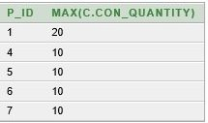

1. Display the seller_id who has the highest selling history

*select o.s_id, count(o.order_no) from orders o group by o.s_id order by count(o.order_no) desc*

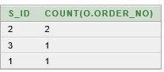

1. . Display the most frequent g_u_id

*select p.c_id , c.c_name , count(p.order_no) as "Total_order" from cart s , g_u_id c where c.c_id = p.c_id group by p.c_id , c.c_name order by count(p.order_no) desc*

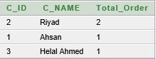

1. Display the mobile number of the customer who id is 2

*select c_id , c_name , c_mobile_no from g_u_user where g_u_id = 2*



1. Find the customer name and his sales man name

*select distinct(c.c_name) , s.s_name from customers c , sales_man s , places p , orders o where c.c_id = p.c_id and p.order_no = o.order_no and s.s_id = o.s_id*

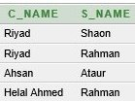

* **Bonus**

**Summarize learning experience from database project**

We have learned many lessons and hade valuable experience doing this project on database system. Though we had several problems doing this project but the achievements were more precious and efficient.

* This project would not be possible without the help of ORACLE SQL APPLICATION EXPRESS software.
* Companies or various institutes use databases because they can store a large number of records, ease of use when locating information, it is easy to add new data and to edit or delete old data, there is ease of storage Data can be imported into other applications
* The whole database model and specially the tables were created very carefully and the joining or linking among the table were done very carefully and also followed DBMS rules
* The constraints such as primary keys or foreign keys of the tables were assigned properly for linking among tables
* By fulfilling these objectives and system policies this project would be a proper and organized database system to run the system.
* The number of levels that the software is handling can be made unlimited in future from the current status of handling up to N levels as currently laid down by the software.
* Efficiency can be further enhanced and boosted up to a great extent by normalizing  and de-normalizing the database tables used in the project as well as taking the kind of the alternative set of data structures and advanced calculation algorithms available.
* We can in future generalize the application from its current customized status wherein other vendors developing and working on similar applications can utilize this system and make changes to it according to their client’s needs.
* Our main outcome would be faster processing of information as compared to the current system with high accuracy and reliability.
* Automatic and error free report generation as per the specified format with ease.
* With a fully automated solution, lesser staff, better space utilization and peaceful work environment, the institute is bound to experience high turnover.
* A future application of this system lies in the fact that the proposed system would remain relevant in the future.

In case there be any additions or deletion of the services, addition or deletion of any individual in any type of modification in future can be implemented easily. The data collected by the system will be useful for some other purposes also.

END**